Basketball Ballarat Technical Officials Handbook

Effective as of November 2019

Basketball Ballarat Technical Officials Program:

Ballarat aims to have the best technical officials program in Victoria. All points within this document we believe will help us achieve this goal so by being involved in BBA, you commit to helping us become the best. You will conduct yourself always in a professional manner and never stoop below.

Chloe Dunmore
Referee Manager
c.dunmore@ballaratbasketball.com

Matt Newton
Competitions and Programs Manager
Matt.newton@ballaratbasketball.com

Kira Irvin
Score Table Officer
ballarattoc@gmail.com

Basketball Ballarat
P.O Box 3 Wendouree 3355
(03) 5338 1220
Website: www.ballaratbasketball.com

Basketball Ballarat Technical Officials Committee

Terry Davies: Chairperson
Matt Newton: Competitions Manager
Chloe Dunmore: Referee Manager
Mark Farrell: Committee Member
Kira Irvin: Committee Member
Donna Dunmore: Committee Member
Kelly Jones: Committee Member

Contents

Code of Conduct 4
Required Code of Conduct 4
Referee Responsibilities 5
Disciplinary Process 6
Non-Attendance/Late Notice Policy 7
Purpose: 7
Referees Procedure: 7
Penalty:. 7
Demerit System 8
Referee Reimbursement Rates 8
Officials Uniform Requirements 9
Policy: 9
Referee Approved Uniform 9
Tournament Attendance 10
Technical Foul Procedures 11

Code of Conduct

Required Code of Conduct
- Treat all players, coaches, spectators, staff and fellow officials with respect.
- It is an expectation that all referees treat all staff of the Basketball Ballarat Association with respect
  - And act in a courteous manner at all times. This includes all Supervisors, Canteen Staff and Administration Staff.
- Understand, adhere and keep up to date with the rules of basketball and local by-laws.
- Promote fair play and appropriate sporting behaviour.
- Always present yourself in a way that encourages others to respect you and your role.
- Use common sense to ensure “the spirit of the game” is not lost by overcalling technical violations or misuse of power.
- Wear correct uniform at all times as per the dress code policy. During breaks, all officials must cover official uniform if exiting the venue for any amount of time.
- No personal belongings such as phones or electronic devices to be left on the score benches during allocated games.
- Ensure your availability is kept current and reflects your availability.
- Be reliable and punctual. It is a requirement that you present to a supervisor in the venue least 10 minutes prior to all games to ensure you are ready at game commencement. Referees to be on court at least 3 minutes prior to scheduled time. Score table are to be on bench at least 5 minutes prior.
- Maintain concentration throughout the entire game.
- Referees to maintain fitness to enable you to keep up with the game to ensure you are in a good position to enable you to referee to the best of your ability for every game. Give yourself the best opportunity to make the correct call by being in a good position on the court.
- Be consistent, objective and courteous in calling all infractions.
- Assist to educate players and fellow officials when they don’t understand why an infraction has been called.
- Any official found to be defacing or vandalising Basketball Ballarat property will face a hearing by the Referees Committee. This includes: Altering rosters, graffiti notice boards and publications in the referees room, as well as any Basketball Ballarat property.
Maintain a disciplined attitude and behave properly when in the stadium (this includes the Minerdome Sports Club & Minerdome Bistro or any other venue where BBA competition is being conducted) whether you are officiating or not, because at all times you are a representative of the Basketball Ballarat Association. All referees must ensure that they are being responsible and act appropriately while in the venue and/or in uniform. Referees must not be in uniform while smoking, and must use designated smoking areas.

Referee Responsibilities

Upon arrival you must check in with your Venue Supervisor or Referee Supervisor. Be ready at your court a minimum of 3 minutes before the scheduled start of your first game. Any subsequent games referees are to go to those games as quickly as possible after fulfilling iPad duties.

On Court Responsibilities
- You must arrive at your court three (3) minutes prior to the start of the match.
- Three (3) minutes must be set on the clock prior to the game commencing. This is mandatory and will not be negotiated. Three minutes must be set, not 23:00.
- One minute must be set and displayed on the clock during the half time break.
- Timeouts must be limited to 30 seconds. Referees must call time in at 20 second mark to allow for teams to re-take the court, and a second whistle (if required) to be given at the 30 second mark. Clock does not start unless referees have blown two warning whistles.
- Ensure that the scoresheet/computer is set up during this warm up period, and if not prompt the teams to enter their details in, to ensure that the game starts on time.
- If the score bench personnel are unsure how to use the alternating possession arrow, explain it to them. Do not do it for them.
- Referees are to make sure all players are complying with jewellery policy which means checks must be made prior to the game. This also includes finger nail checks if necessary.
- Uniforms need to be checked to ensure all players are in correct team uniform and if required the penalties should be applied once the game commences. If unsure, speak with supervisor to have final decision.

Referee and Scoretable Clinics / Development / Action Days
It is compulsory to attend all TOC development days & BBRA General Meetings to attain any update on rule changes and mechanics. You must come with an attitude and willingness to learn and participate.
You are only required to attend clinics for your area of officiating.

Disciplinary Process

Members, parents, officials and volunteers at our Association are continually reminded that the responsibility for the image of the Association and its environment is largely in their hands. Our obligation is to ensure that members of the Association, family members, friends and volunteers are comfortable in and around the venues we use for training or competition games or when performing duties for the Ballarat Basketball and that all parties feel safe at all times.
All who participate in any activity need to be fully aware of their legal and moral responsibilities to our total membership as well as the image they portray to others involved with Ballarat Basketball and to the broader community.
Not only do we expect people to adhere to the Basketball Victoria Codes of Conduct, but we also expect all parties to adhere to the spirit of our rules and the sports.

The Ballarat Basketball Technical Officials Committee does not tolerate inappropriate behaviour which includes, but is not limited to:

- Threatening or intimidating behaviour by any person or group towards any other person, either in person or by phone or in writing.
- Offensive language
- Engaging in poor off court and social media behaviours
- Any behaviour which interferes with the enjoyment, safety and wellbeing of others
- Failure to obey the directions of Ballarat Basketball TOC

You are expected to comply with the Basketball Victoria Codes of Conduct at all times.
The following process has been approved by the TOC and supported by Basketball Ballarat for use when any person breaches the Codes of Conduct or Spirit of the Rules.
Any breach of this code may result in the following:
- A written warning may, in the appropriate circumstances, be sent to the offending parties by the TOC.
- A meeting with the TOC may take place to discuss the breaches and exclusion from TOC activities.
- The matter may be referred directly to the TOC and Basketball Ballarat CEO (or his delegate) to consider sanctions.
- Right to refuse membership to any person at any time as per the Constitution.

Non-Attendance/Late Notice Policy

Purpose:
- To provide officials with steps to take if they are unable to fulfil rostered appointments.
- To ensure that there will always be two referees on each court and appropriate number of scorers.

Referees Procedure:
Referees who need to withdraw from rostered games must contact Referee Manager by email, providing as much notice possible.

If less than 48 hours’ notice is provided, it is the responsibility of the referee to source their own replacement with other suitable referees of same grade or higher. You can do this via the Ballarat Basketball Technical Officials Facebook page or via contacts you have. It is expected that you will confirm with the Referee Officer once complete so rosters can be fixed accordingly.

Note: If games are rejected via My Roster system, a valid note must be attached to the rejection submission. Failure to provide a valid reason will result in consequences.

If the referee advises Basketball Ballarat that they have been unable to source a replacement, then the names of those unavailable replacement referees must be provided on request.

Non-emergency pull offs such as school excursions, parties, scheduled playing games or prior booked appointments are not deemed valid reasons for rejection of games. Therefore, you will be required to honour your games or find a fill in as per above details.

For emergency pull offs such as family emergencies or illness (may be asked to provide a medical certificate) you must contact the Referee Officer as soon as possible. Please note that these may require further information and/or verification of event.

Breaches will include:
- Failure to provide insufficient notice to Basketball Ballarat of your unavailability.
- Failure to provide Basketball Ballarat of non-attendance.
- Notification of non- attendance but a refusal to attempt to find a replacement.
- Notification of non-attendance but declines to advise Basketball Ballarat as to who was contacted in an effort to self-replace.
- Notification of non attendance and replacement found of lesser experience.

Penalty: May include, but is not limited to, the referee being paid one grade less on following shift, and resulting in a strike according to the disciplinary process.

Score Table Procedure:
If you are unable to fulfil your games, contact the Score Table Officer as soon as possible with valid reasoning behind withdrawing from games. Please endeavour to inform Officer of availability changes with as much notice as possible.

Demerit System

The Demerit System sees referees being held accountable for their actions.
Once referees have obtained a total of 3 strikes, they will be penalised with the deduction of one game match payment on the current shift. Referees will also receive correspondence from the TOC regarding this. The strike system will reset at the beginning of each season.

Referees obtain one strike for the following criteria:
- Failure to show up for rostered games without acceptable reason
- Pulled off rostered games without acceptable reason
- Failed to complete rostered games without acceptable reason
- Referee out of uniform without acceptable reason
- Late for games without acceptable reason
- Did not fulfil games, nor did they find a replacement to cover games

Referees will receive a warning from the Referee Manager/TOC once they obtain two strikes, then a letter on the third strike stating the pay deduction. Reasoning is at the discretion of the TOC or their representative, this may include sudden illness, family emergency, etc.

Appeal Process:
Appeals to any strikes or deduction in can be forwarded to the TOC via email. Please note this will not be processed straight away due to the Committee being a volunteer base and only meeting monthly/bimonthly.

Referee Reimbursement Rates

Referee pay and reimbursement rates can be found via the VBRA website:

http://vbra.basketball.net.au/resources/2019-reimbursement-rates-2/

Officials Uniform Requirements

Policy:
All officials will be expected to follow the BBA uniform policy whenever officiating in competitions under the control of the Basketball Ballarat Association (BBA) or competitions that BBA are responsible for supplying referees to.

Referee Approved Uniform

- Approved Black and White referee shirt or Green shirt tucked in
- Black pants or approved BB or BV referee shorts (summer use)
- Black belt (if required)
- Predominantly Black Sports Shoes with non-marking soles
- Approved Basketball Ballarat / Basketball Australia Jacket
- Undergarments may be worn but must be fully black if visible

Score Table Approved Uniform
- Black dress pants, shorts or skirt (appropriate length and dependant on weather)
- VBSA polo shirt
- Enclosed black shoes
- VBSA jacket or plain black jacket
- Undergarments may be worn but must be fully black if visible

All Referee Finals Appointments
For Semi Finals, Preliminary Finals and Grand finals it is a requirement all referees must wear long black pants, referee shirt listed above and shoes listed above. Referee jackets and undergarments are not permitted unless cleared by the TOC less than 1 week prior to finals games commencing.

Tournament Attendance

All referees anticipating to attend a tournament, must advise the BBA by filling out a Basketball Ballarat Tournament Attendance Form no later than two weeks prior to the tournament.

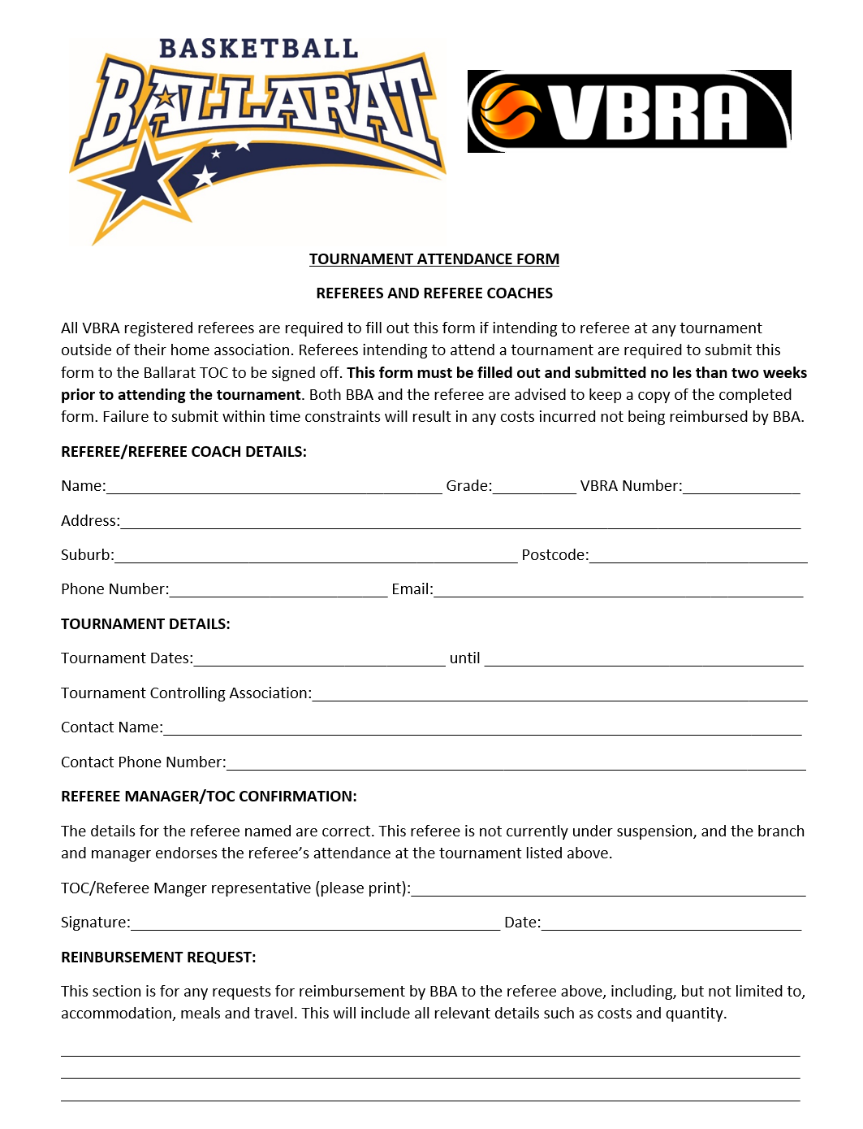

Technical Foul Procedures

Referees aim to use game management to avoid technical fouls being administered during competitions.
All technical fouls administered, must have accompanying paperwork handed to supervisor on the day of tech being given. An adequate description must be filled out on the back of the paperwork, including events leading up to technical. Regardless if one week suspension is given to a player or not, paperwork MUST be filled out (category 2 covers infringements where player is not suspended).
